***1. Delete DB Server and DBA PC in VirtualBox***

- Delete all portforwardings in the VirtualBox

**2. Download Core Server and Manager PC from file server (Challenge)**

- The new images for the CentOS server and Windows 8 are Core Server.ova and ManagerPC.ova respectively.

**3. Mount Core Server and Manager PC on VirtualBox**

- Click Open

**4. Make a meterpreter connection to Manager PC**

**5. Find some connection Information in ~~DBA PC~~ Manager PC**

**6. Crack the root password to ~~DB Server~~ Core Server**

**7. Connect to ~~DB Server~~ Core Server from your PC**

**Some useful references and hints:**

[**https://github.com/rapid7/metasploit-framework/blob/master/documentation/modules/post/windows/gather/credentials/securecrt.md**](https://github.com/rapid7/metasploit-framework/blob/master/documentation/modules/post/windows/gather/credentials/securecrt.md)

<https://github.com/HyperSine/how-does-SecureCRT-encrypt-password>

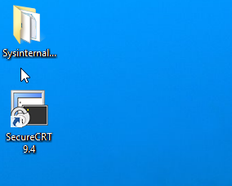

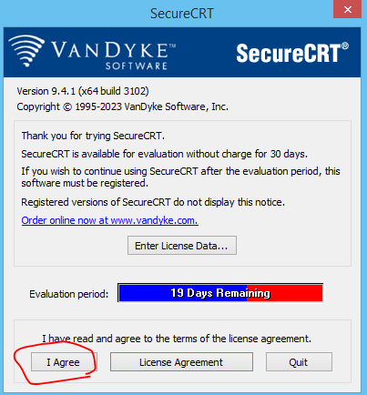

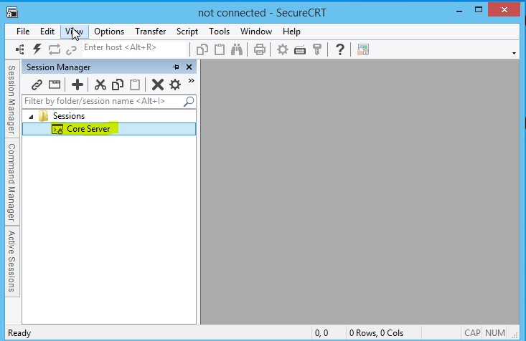

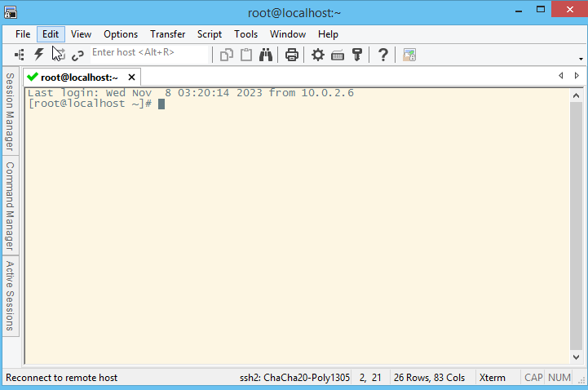

**3. Make another route via Kali**

- make <Forward Tunnel> in your PC

Your PC> ssh -L 3306:localhost:8000 root@192.168.56.111

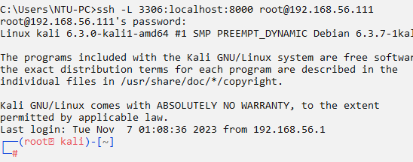

- make <Remote Tunnel> in Kali

Kali> ssh -R 8000:10.0.2.5:3306 root@192.168.56.111

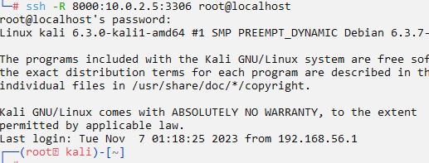

**4. Connect Again**

- Change connection address like this

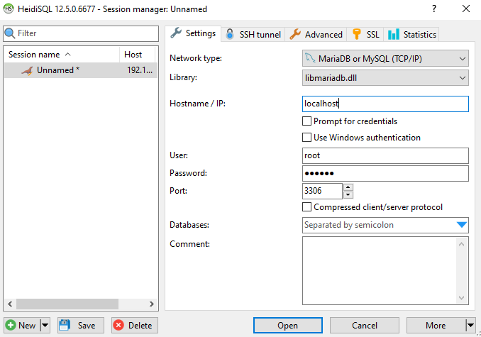

- Connect

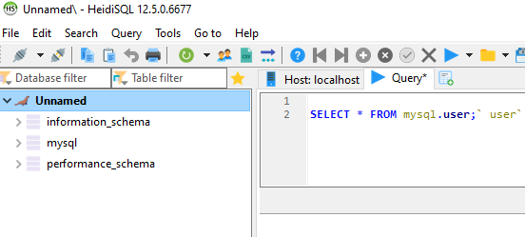

Win!!